**Performance Testing Tools**

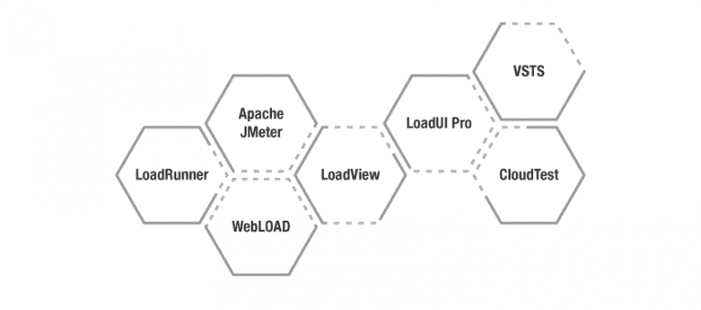

**1.LoadRunner**

It is the most widely used tool to test applications, measure system behavior and their performance under varying loads.

This tool supports all advanced technologies like Ajax, Flex, HTML5.0, Java, SOAP, Citrix along with all other legacy technologies.

**2.JMeter**

It is an important open-source tool used to test the performance of both static and dynamic applications.

It is a Java-based application used for [load and performance testing](https://www.testingxperts.com/services/performance-testing/),

**3.WebLOAD**

This is a widely used tool by enterprises for [testing web and mobile applications](https://www.testingxperts.com/blog/mobile-app-testing-factors). It is an effective tool as it combines performance, scalability, and integrity as a single process for testing applications.

**4.LoadView**

It is used for cloud-based load testing and empowers DevOps teams to efficiently test websites, web-apps, and application programming interfaces (API’s) with thousands of concurrent users.

**5.LoadUI Pro**

This tool is used for load testing REST, SOAP API’s, databases and microservices.

**6.VSTS**

VSTS stands for Visual Studio Team Services; is an extension of Microsoft Visual Studio.

 The tool is used to load test mobile applications or website’s performance before their launch to check any performance bottlenecks even before it reaches the customers.

**7.CloudTest**

This tool helps to stress the test the environment to ensure the website or an application is stable even under spikes or in heavy traffic.